Voice Coach — Análisis de voz
Idioma: English · Duración: 28s · Palabras: 63 · Ritmo: 133 ppm · Positividad: 68% · Muletillas: 0 · Generado: 7/11/2026, 1:22:16 PM

Métricas


Arco de sentimiento
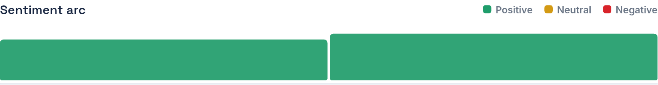

Transcripción
When we could say this from the USA, come to Latin America, they are looking for competitive salaries and others who can spend more to give last year, I decided to pursue a career in a corporate, even in a musician's teams, a company, an studying chemistry and English. This is a true path that through hard work, you can achieve your goals.
Color del texto — Verde: positivo · Amarillo: neutral · Rojo: negativo

